**Tableau Introduction-Assignment 1**

1. “twbx” is a bundled workbook for Tableau. The original .twb file is bundled with the data source in this package. It can be compared to a compressed file. It contains all the information and instructions required to operate in Tableau. Since the data is contained within the .twbx file itself, one can still access and use it without a network or Internet connection. The .twb file and the data source can be separated from the .twbx file by unpacking it. Pick up any dataset of your choice, create a simple bar chart using the fields of the dataset and save the visualization created in .twbx format. Analyze the properties of the newly created twbx file and segregate the .twbx file into .twb and data source.

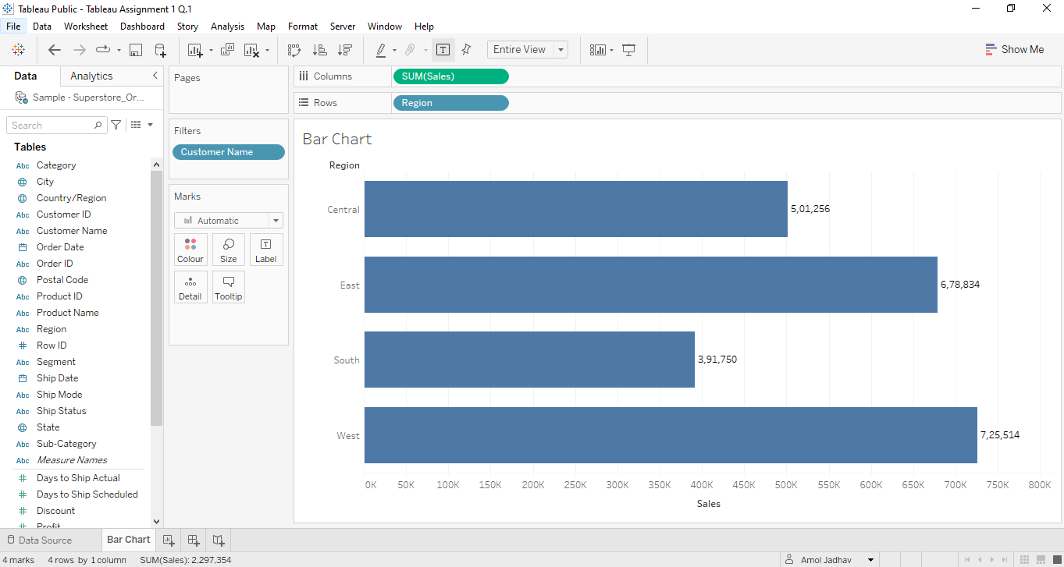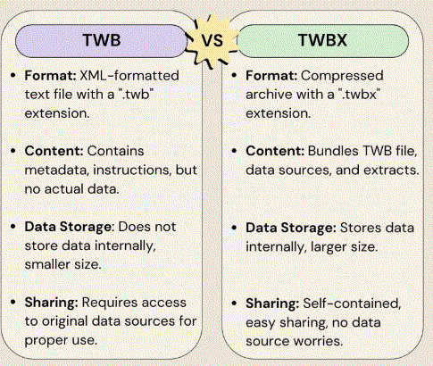

1. Briefly explain the utility of the Tableau bookmark feature and create a simple bookmark file. Observe the format of the bookmark file and mention the location in which it is saved.

Bookmarks contain a single worksheet and are an easy way to quickly share your work. For more information, see Save a bookmark(Link opens in a new window). Packaged Workbooks (. twbx) – Tableau packaged workbooks have the .

You can save a single worksheet as a Tableau bookmark. When you save the bookmark, Tableau creates a snapshot of the worksheet. Bookmarks can be accessed from any workbook using the Bookmarks menu. What is a bookmark/favourite? A bookmark is a web browser feature used to save a web site's URL address for future reference. Bookmarks save user and browser time, which is especially useful for Web pages with long URLs or accessing a specific part of the site that might not be the homepage for the site.

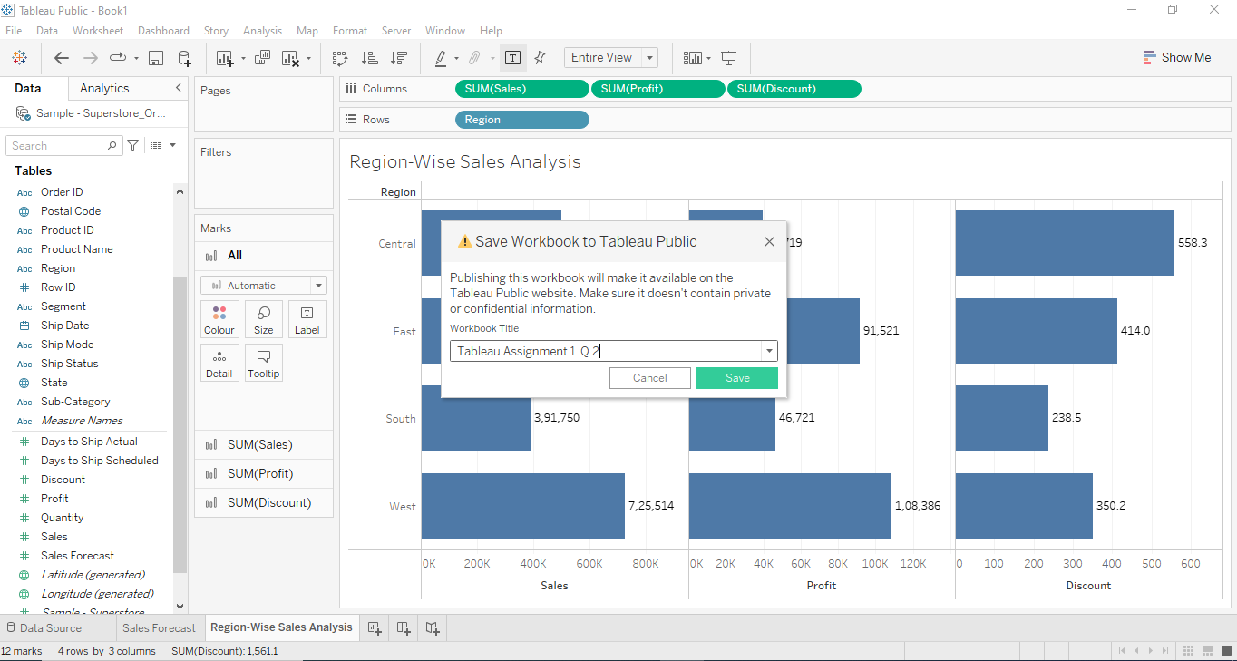

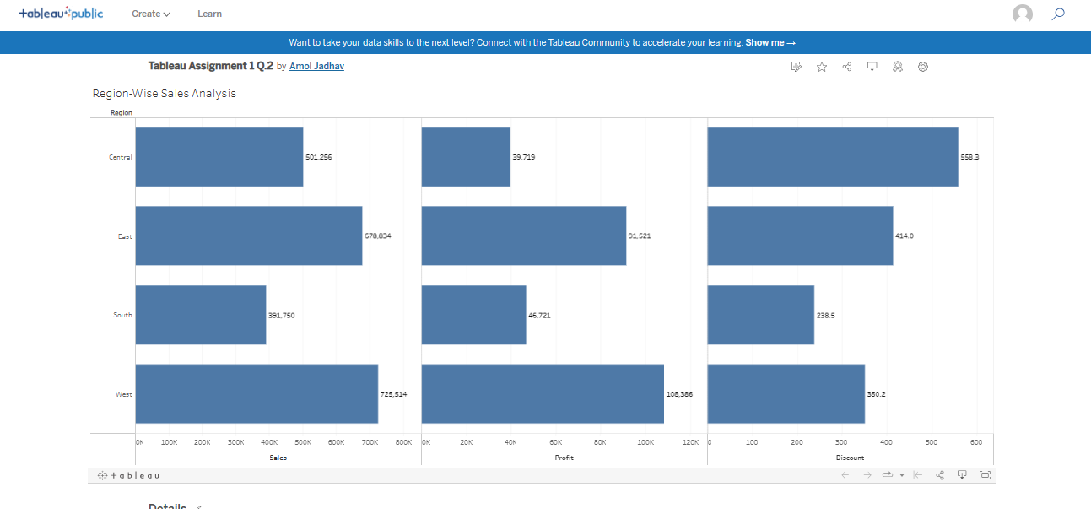

1. Using the “Sample-Superstore.xls” file, create a scatter and a bubble plot between different measures in the dataset and observe the type of correlation (negative or positive or no correlation) between them. Draw a comparison between the bubble chart and the scatter plot.

The bubble chart and scatter plot in Tableau are both fantastic ways to represent data visually. While they share some similarities, they also have their own unique characteristics.

A bubble chart, as the name suggests, uses bubbles or circles to display data points. The size of each bubble represents a third variable, in addition to the two variables plotted on the x and y axes. This allows us to visualize three dimensions of data in a single chart. It's like having a colorful party of bubbles, with each bubble conveying valuable insights!

On the other hand, a scatter plot is a classic data visualization technique. It uses individual data points plotted on a two-dimensional plane, with one variable on each axis. This helps us understand the relationship between the two variables and identify any patterns or trends that may exist. It's like connecting the dots to reveal the bigger picture!

So, to summarize, the bubble chart brings an extra dimension to the scatter plot, incorporating the size of bubbles to represent a third variable. Both visualizations are excellent tools for exploring data, but the bubble chart adds an extra layer of depth and complexity. It's like taking a scatter plot on a colorful, bubbly adventure!

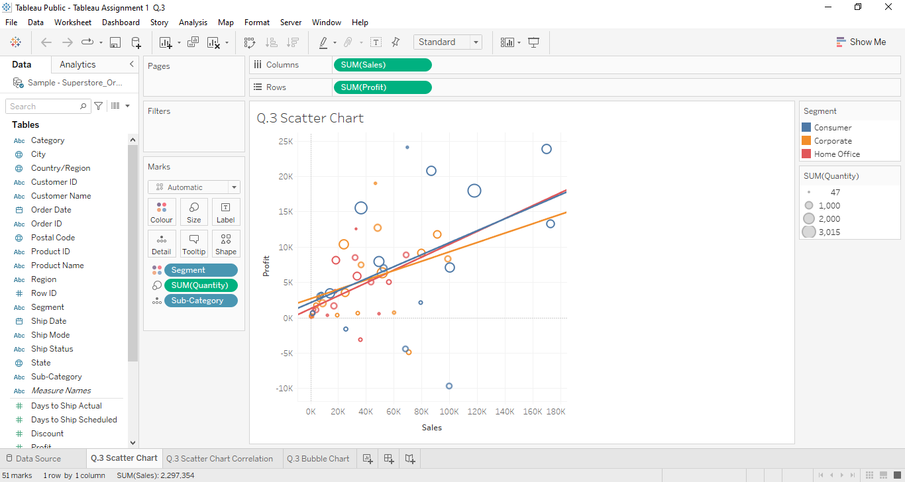 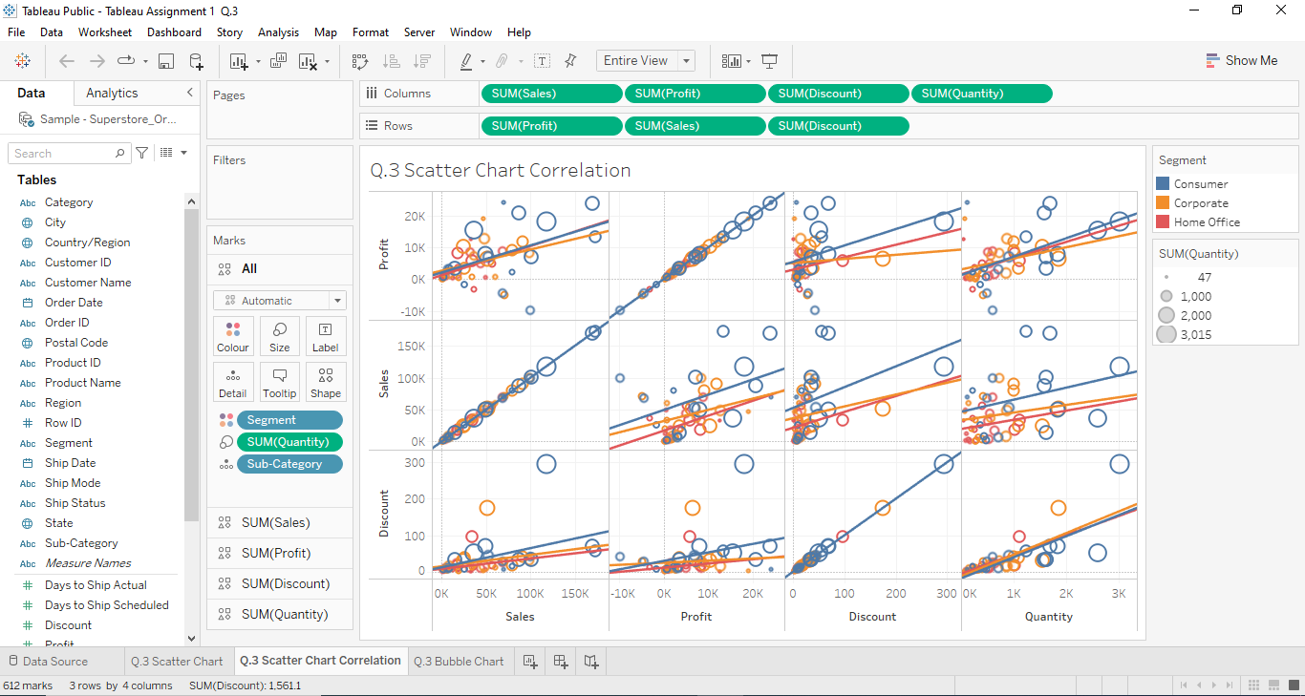 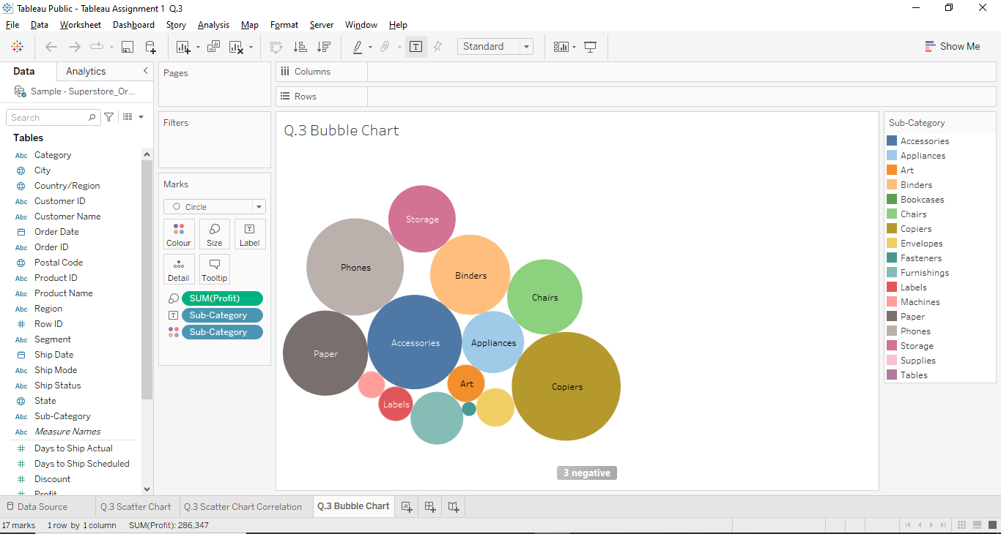

1. Consider that you are an HR representative for a multinational company. The staff database is under your control. There are certain details regarding employees that you must never divulge. However, there are many bits of information about employee abilities and skills that may be shared. Using the data extract option in tableau, build a packaged worksheet and use the option "Hide All Unused Fields" in the data extract feature to hide all the fields- dimensions and measures which you haven’t used in the visualization and do not wish to share with employees. Feel free to use any HR dataset or you may even create a dummy data for illustration purpose.

Hide Column

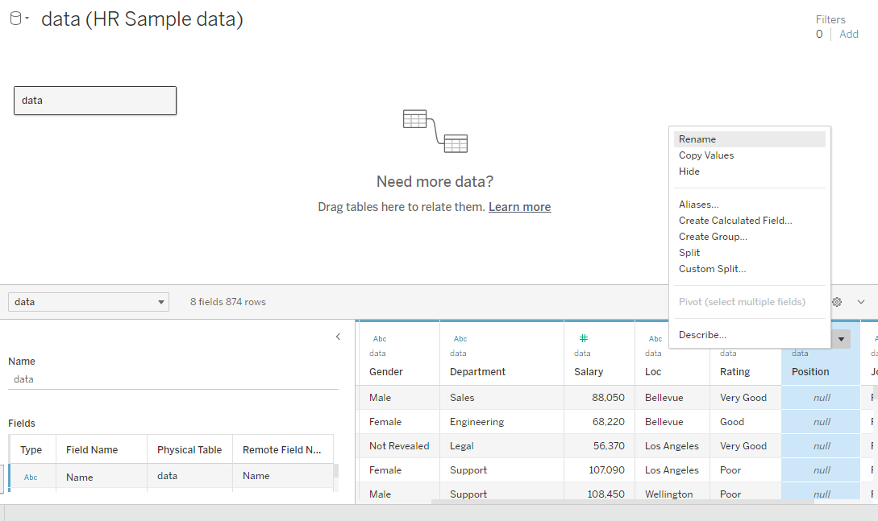 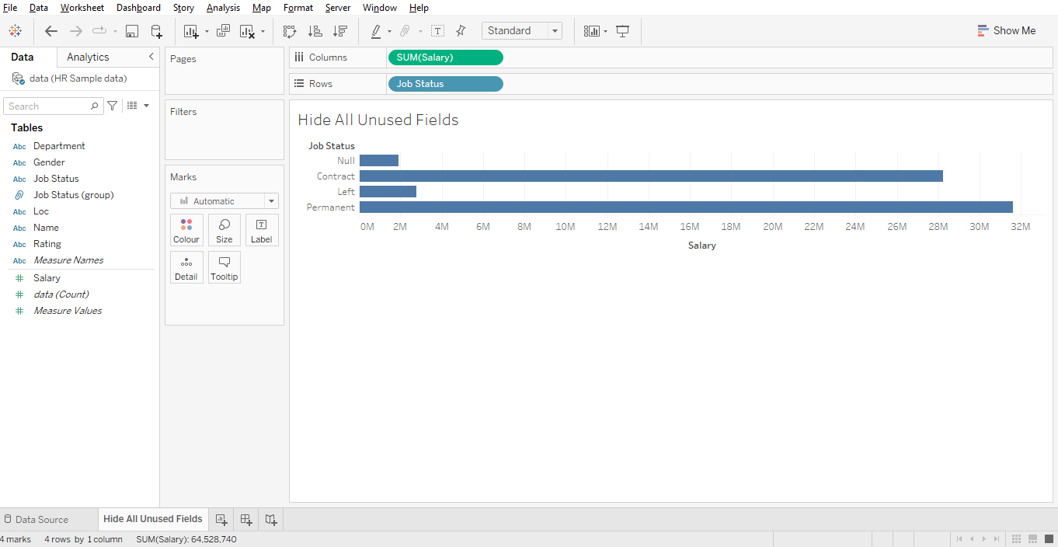 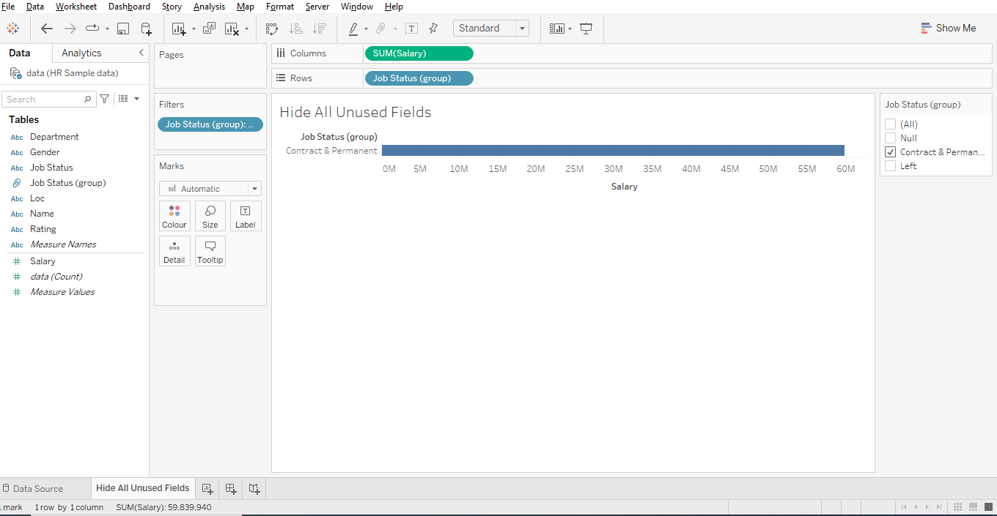 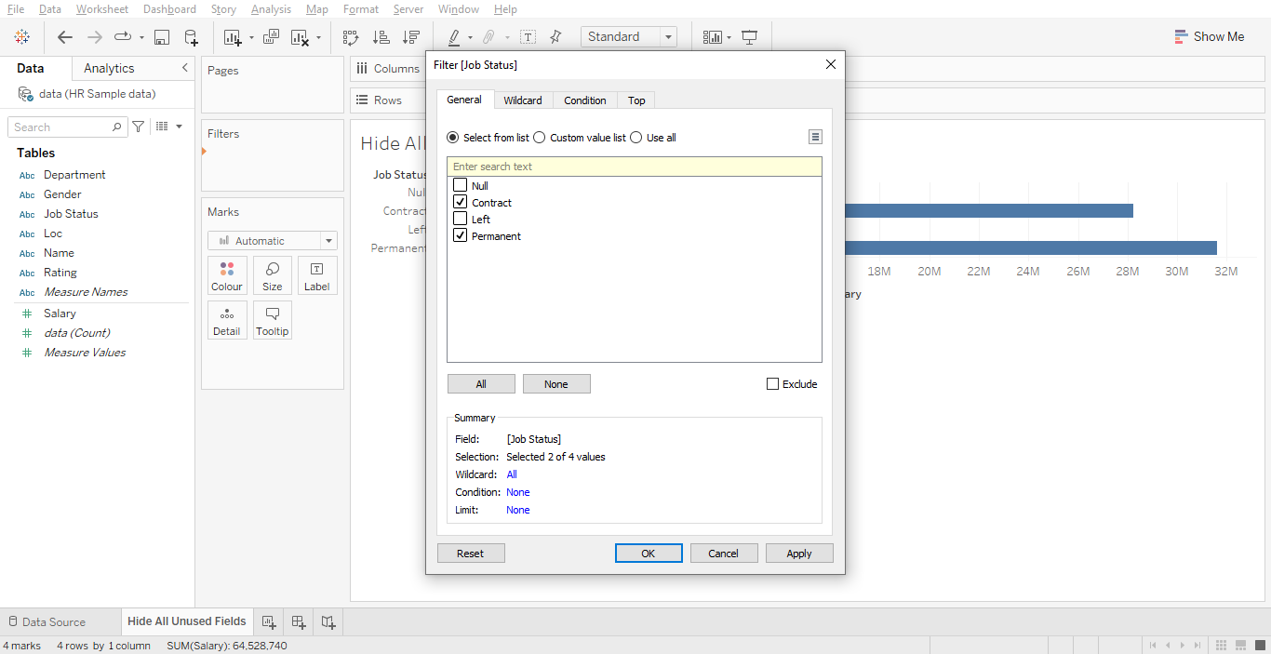 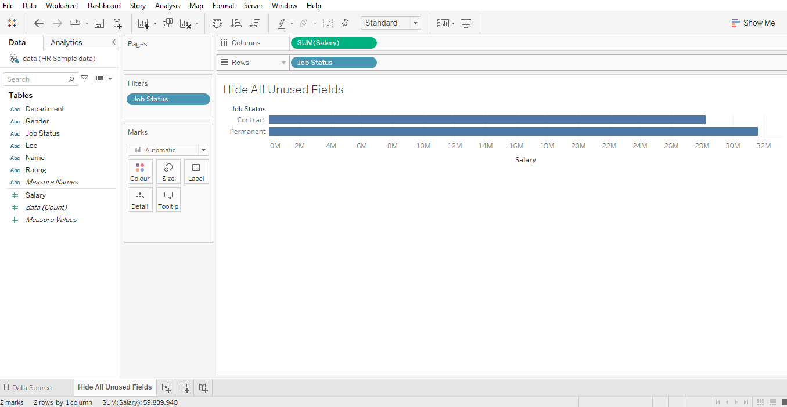

1. Discuss the differences between the “Measure Names” and “Measure Values” pre-defined features in Tableau. Using the “PowerStore_USA” dataset available in your iNeuron resources, create a visualization using “Measure Names” and “Measure Values” and mention the fields that fall into each category- “Measure Names” and “Measure Values”.

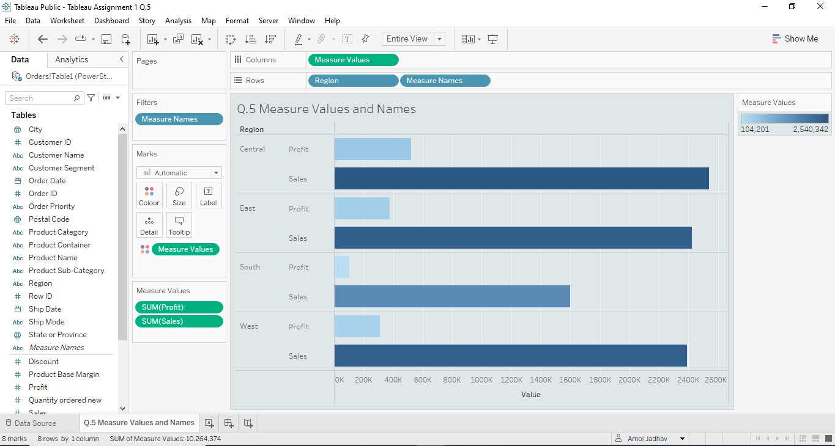

[*PFA links for the datasets used.*](https://drive.google.com/drive/folders/123UyMRbrReCjyn1K4g_FhsjKx6cP4zLH?usp=sharing)